**Appendix A**

**User Guide**

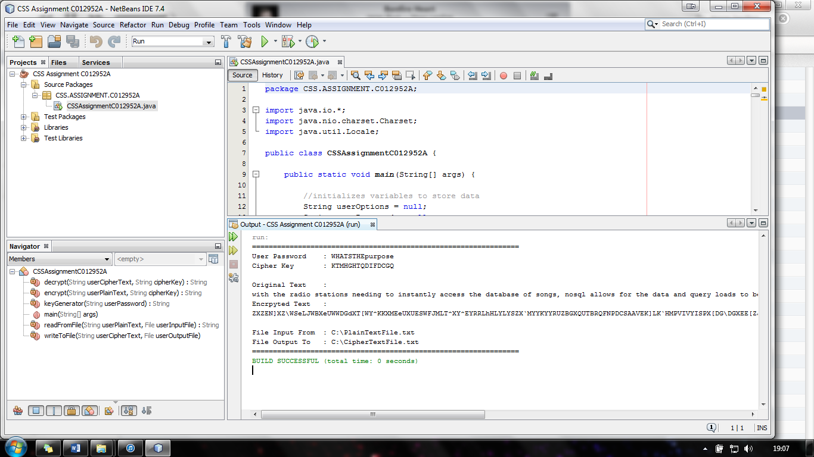

**Encryption & Decryption Software Implemented using Java**

**User Guide**

**By Harry Clewlow**

**Contents**

1. Overview Page 1
2. Using the Application
   1. Setting up the files Page 1
   2. Preparing to Run the Application Page 2
   3. Encryption using Application Page 3
   4. Decryption using Application Page 3-4
   5. Closing the Application Page 4
   6. Viewing Resulting Encryption or Decryption Files Page 4

**Overview**

The encryption & decryption software implemented using java application guide will explain and demonstrate how to use the applications features such as encryption and decryption, troubleshooting any problems that might occur, some frequently asked question and a glossary of any technical terms used.